

**NMAM INSTITUTE OF TECHNOLOGY**

(A unit of Nitte Education Trust)

Nitte - 574 110, Karkala taluk, Udupi Dist., Karnataka

**Department of Computer Science and Engineering.**

**RDBMS PROJECT REPORT ON**

**MEDICALC - A Clinic Management Tool**

***PROJECT ASSOCIATES***

**Ashwin P M Ankush Kumar N**

**4NM17CS035 4NM17CS022**

**V Sem, Sec 'A' V Sem, Sec 'A'**

**Dept of C.S.E Dept of C.S.E**

**PROJECT GUIDE**

**Mr. Roshan Fernandes**

**Dept of C.S.E.**

**NMAMIT**

**ABSTRACT**

Clinics work the same way as that of a hospital but on a smaller scale. They do need to maintain their data. Hence this project is done on that idea to provide an easy and helpful interface to take care of patient, doctor, etc. records in a consistent manner. The tool can store all details of day to day activities of the clinic is stored in this tool via the database that it uses. This tool simplifies the task of handling large records and giving proper outputs.

**TABLE OF CONTENTS**

**Chapter Page no.**

**1. CERTIFICATE 4**

**2. ACKNOWLEDGEMENT 5**

**3. INTRODUCTION 6-7**

**4. PROBLEM STATEMENT 8**

**5. DATABASE DESIGN 9-10**

**6. FRONT END TECHNOLOGY 11**

**7. BACK END TECHNOLOGY 12**

**8. SCREENSHOTS 13-25**

**9. CONCLUSION 26**

**10. REFERENCES 27**

**CERTIFICATE**

Certified that the project work carried out by Ashwin P M (4NM17CS035) and Ankush Kumar N(4NM17CS022) bonafide students of NMAM Institute of Technology, Nitte in fulfilment for the Relational database Management System lab in Computer Science and Engineering during the academic year 2019-2020.

Signature of the Examiners:

Signature of the Guide:

1.

2.

**ACKNOWLEDGEMENT**

The satisfactions that accompany the successful completion of any task would be incomplete without the mention of the people who made it possible. So we acknowledge all those whose guidance and encouragement served as a beacon of light and crowned our efforts with success.

We are thankful to our project guide, Mr. Roshan Fernandes, Dept. of CSE for his valuable guidance and advice. His willingness to motivate us contributed tremendously to our project.

We would like to place on record our deep sense of gratitude to Dr. K. R. Udaya Kumar Reddy, HOD-Dept. of Computer Science and Engineering, NMAMIT, Nitte for his generous guidance, help and useful suggestions. We also acknowledge and express our sincere thanks to our beloved Dr. Niranjan. N. Chiplunkar, Principal, NMAMIT, Nitte who is a source of inspiration to us.

We thank all the Teaching and Non-Teaching staff members of the department of CSE for providing resources for the completion of the project. A special thanks goes to our parents, friends and relatives for supporting and encouraging us in all ways thus making our project

successful. Finally, we thank all those who have contributed directly or indirectly in making this project a grand success.

Ashwin P M Ankush Kumar N

(4NM17CS035) (4NM17CS022)

**CHAPTER 3**

**INTRODUCTION**

INTRODUCTION

1.1 Problem Definition:

Handling large data in clinics that may age to many years is a great problem if the clinic is using a traditional method of storing their records. Hence a more lenient method to store clinic records is required.

1.2 Non-Functional Requirements:

* Accuracy
* Consistency
* Durability
* Ease of Usage

1.3 Functional Requirements:

* Addition of Clerks
* Deletion of Clerks
* Addition of Doctors
* Deletion of Doctors
* Addition of Nurse
* Deletion of Nurse
* Addition of Patient
* Giving Prescription
* Admitting Patient
* Discharging Patient
* Adding Medicine
* Adding Rooms
* Deleting Medicine
* Deleting Rooms
* Retrieving Patient Details
* Retrieving Prescription Details

**CHAPTER 4**

**PROBLEM STATEMENT**

To build a tool to handle clinic records and to maintain concurrency of records and large amount of records being generated by the clinic.

SYSTEM STUDY

EXISTING SYSTEMS:

Currently, hospitals are equipped with such hospital management systems which use a highly sophisticated tools to carry out their work. The system built here is a small scale alternative of such hospital management systems built for clinical use.

OBJECTIVES OF THE STUDY:

The objective is

To develop a tool to manage clinical records.

**CHAPTER 5**

**ER-Diagram:**

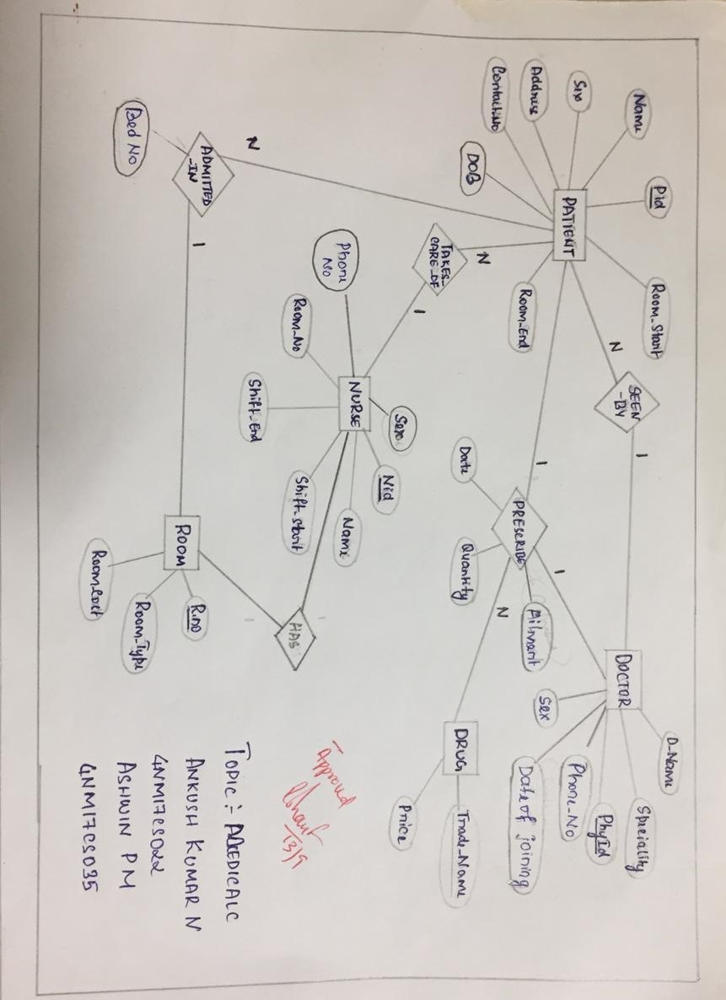

**E-R Schema:**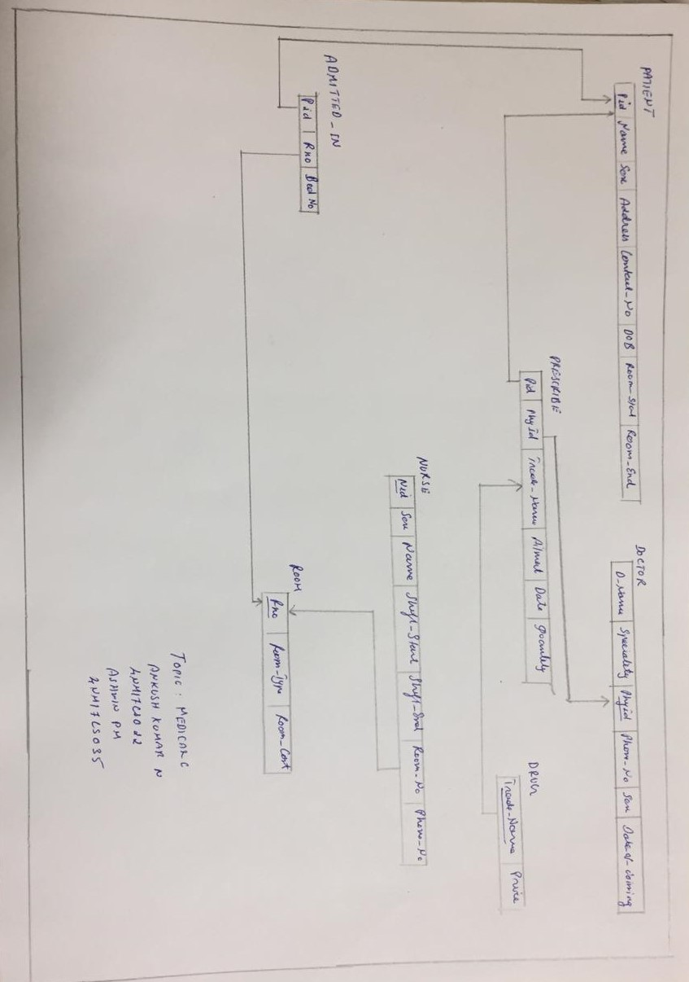

**CHAPTER 6**

**FRONTEND TECHNOLOGY**

**List of technologies for frontend**

1. **JAVA**

It is a programming language used to build application for real-time and desktop environments. Java is used as a controller and a model in this project.

**2. JAVAFX**

JavaFX is a GUI tool build for designing GUI applications in java. It uses an MVC architecture to carry out the design process in building the application.

**CHAPTER 7**

**BACKEND TECHNOLOGY**

**List of technologies for Backend**

**JDBC**

Java DataBase Connectivity is a tool used to connect to the database in java. It uses various libraries and files to establish a secure connection between the java program and the database being used.

**Database:**

**MySQL:**

MySQL is an open-source relational database management system. Its name is a combination of "My", the name of co-founder Michael Widenius's daughter, and "SQL", the abbreviation for Structured Query Language.

**Chapter 8**

**SCREENSHOTS**

**Home Screen:**

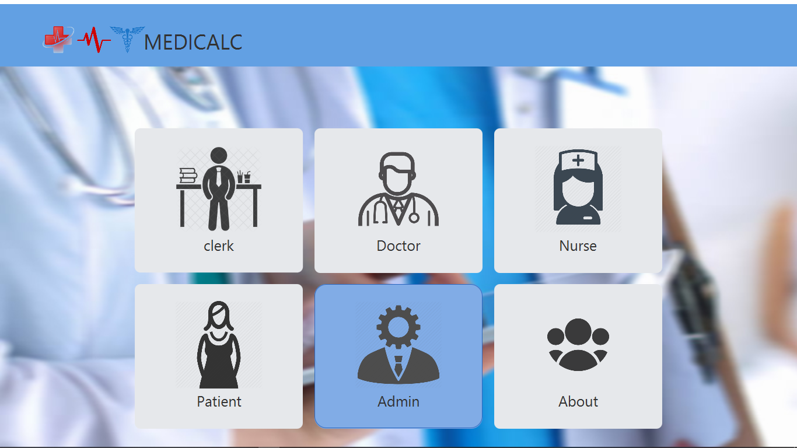

**ADMIN SCREEN WITH ALL ITS FUNCTIONALITIES:**

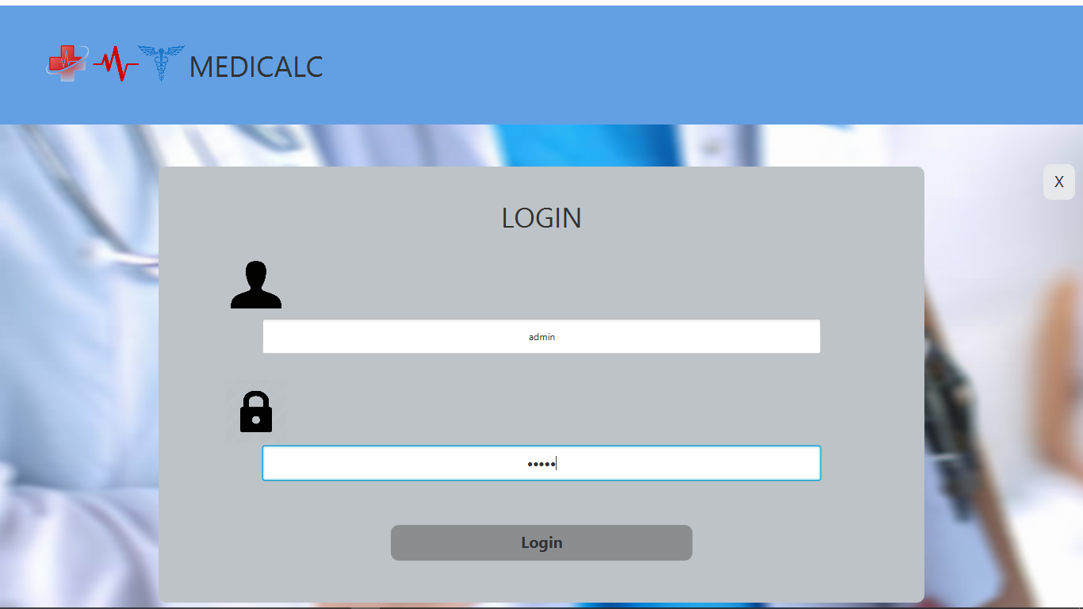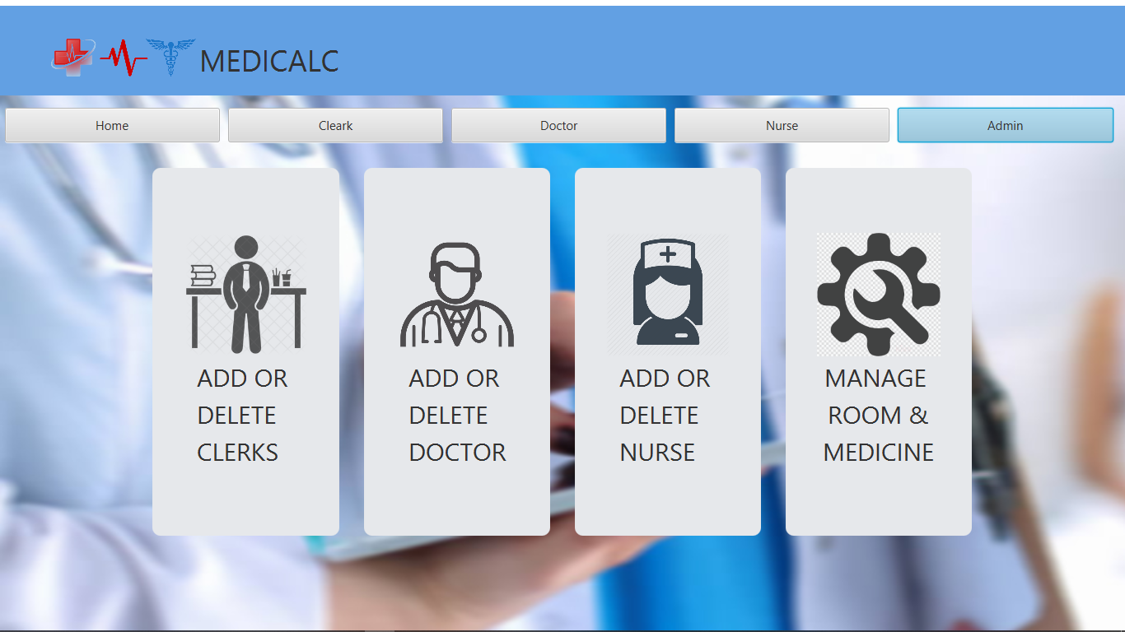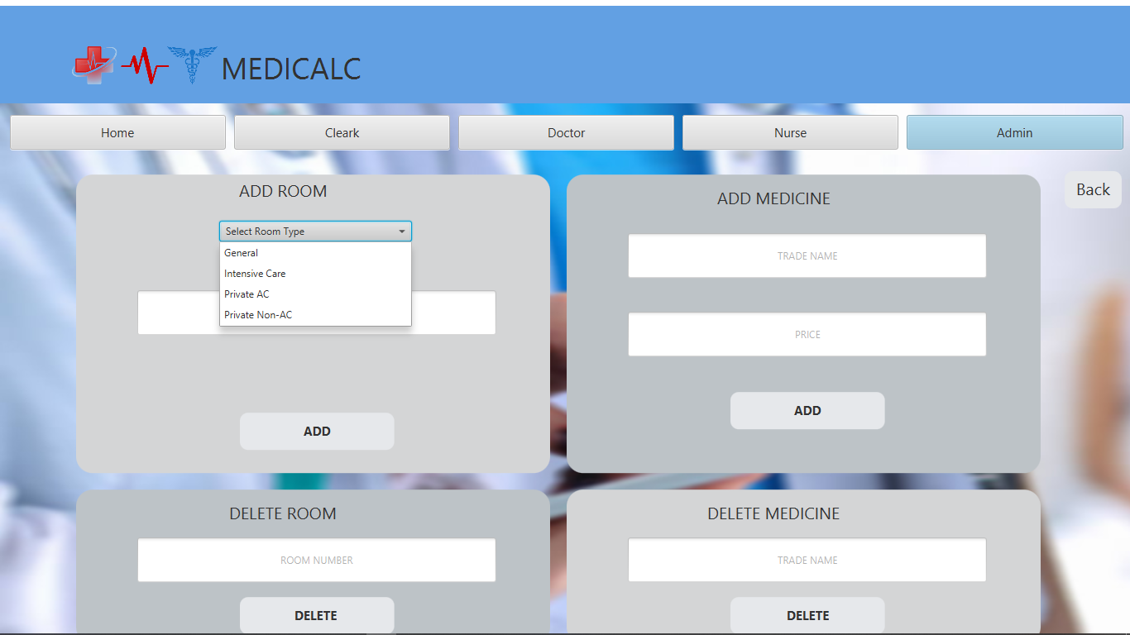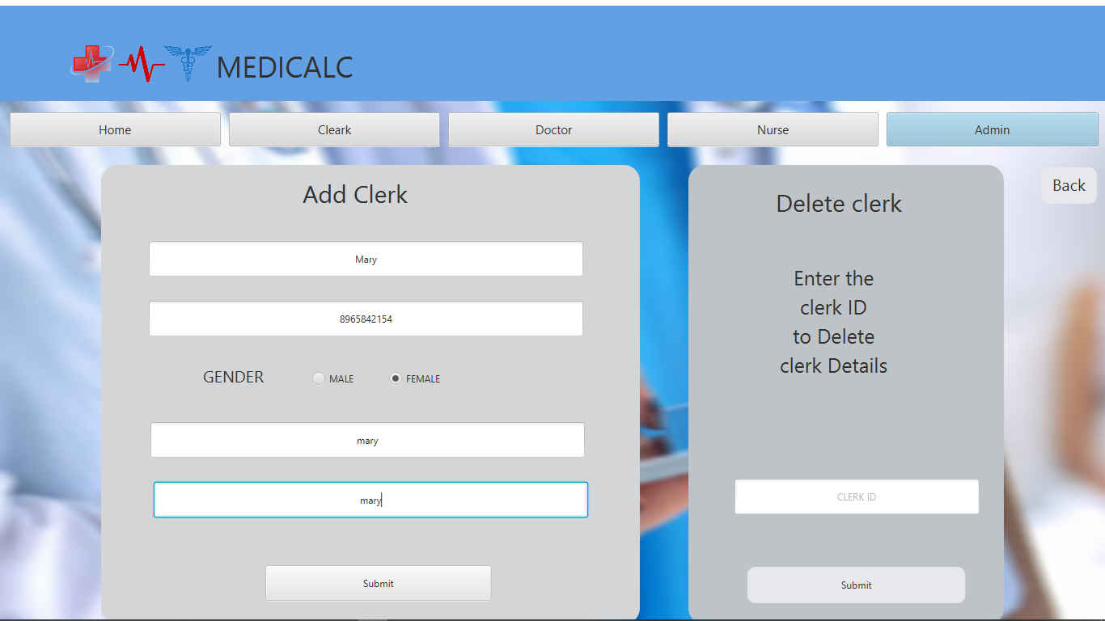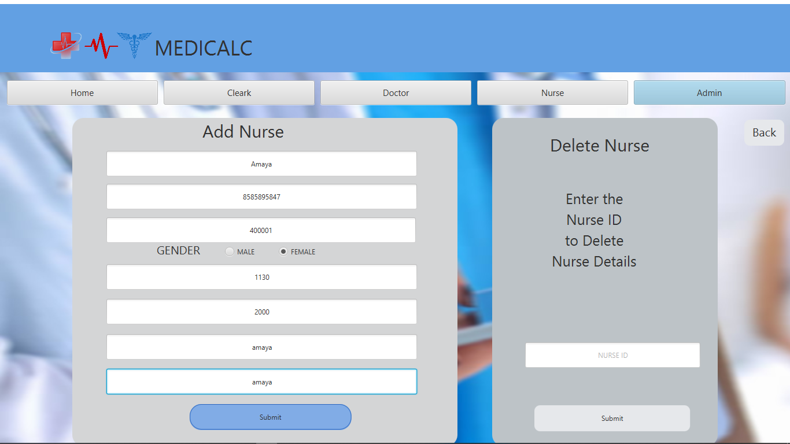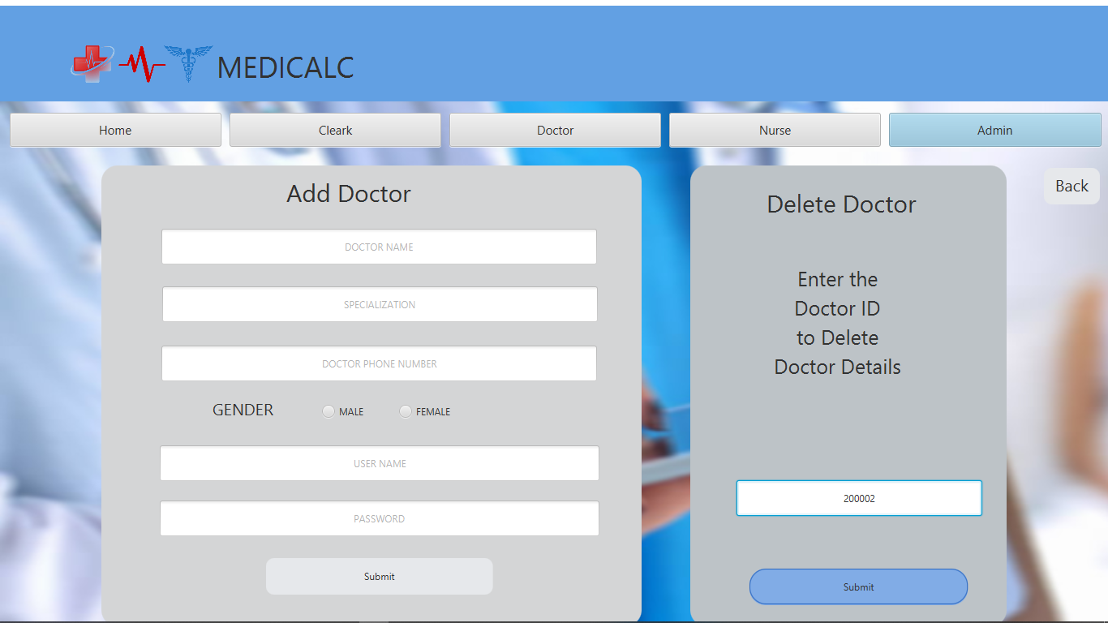

**CLERK SCREEN:** 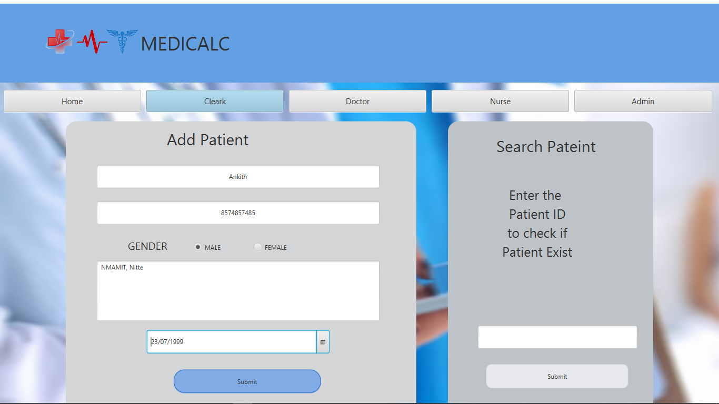

**DOCTOR SCREEN:** 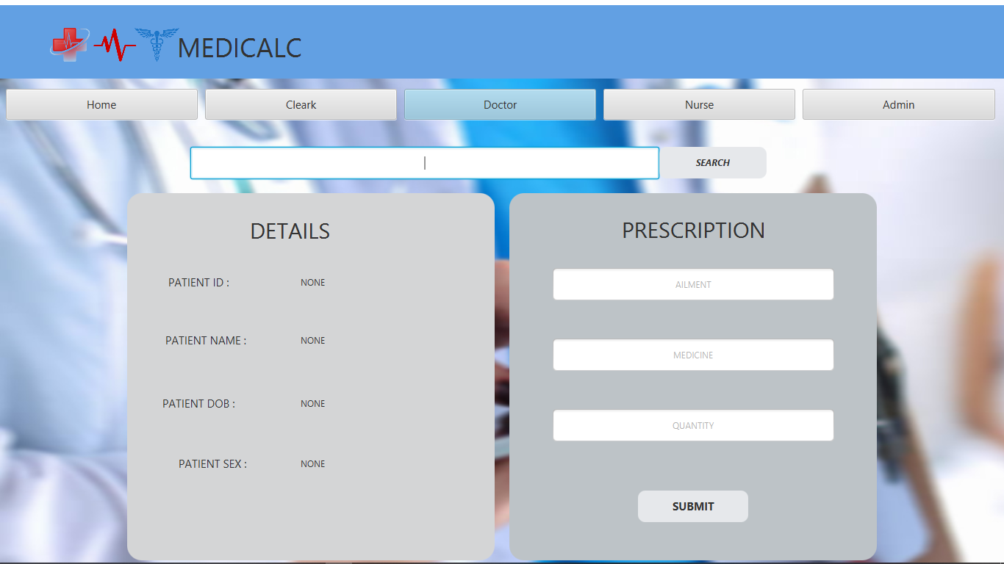

**NURSE SCREEN:** 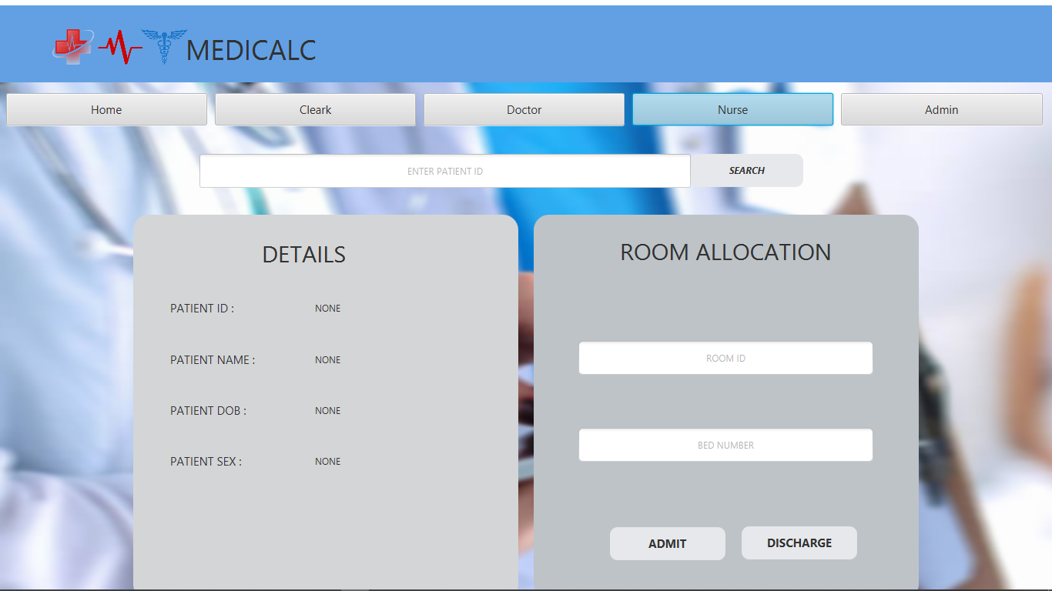

**PATIENT AND PRESCRIPTION DETAILS:**

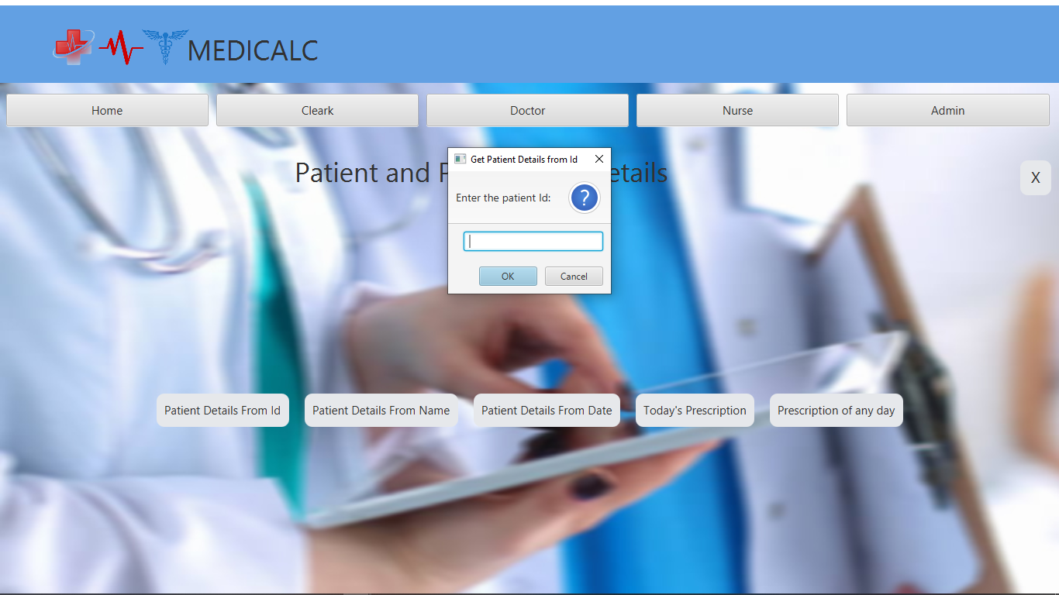 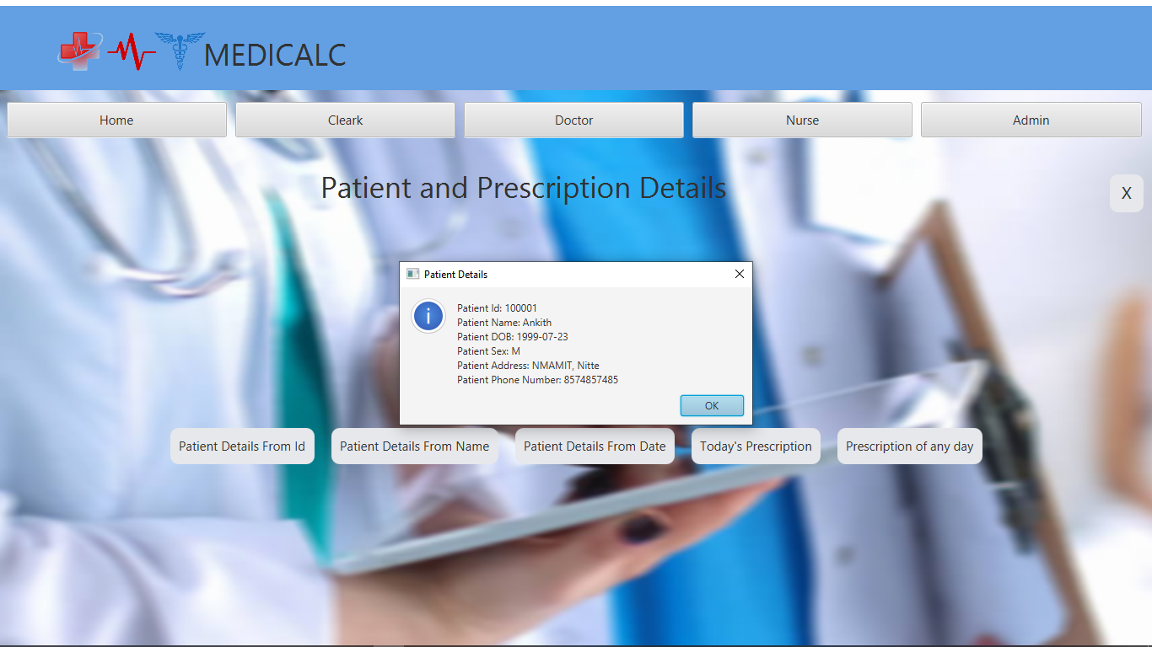 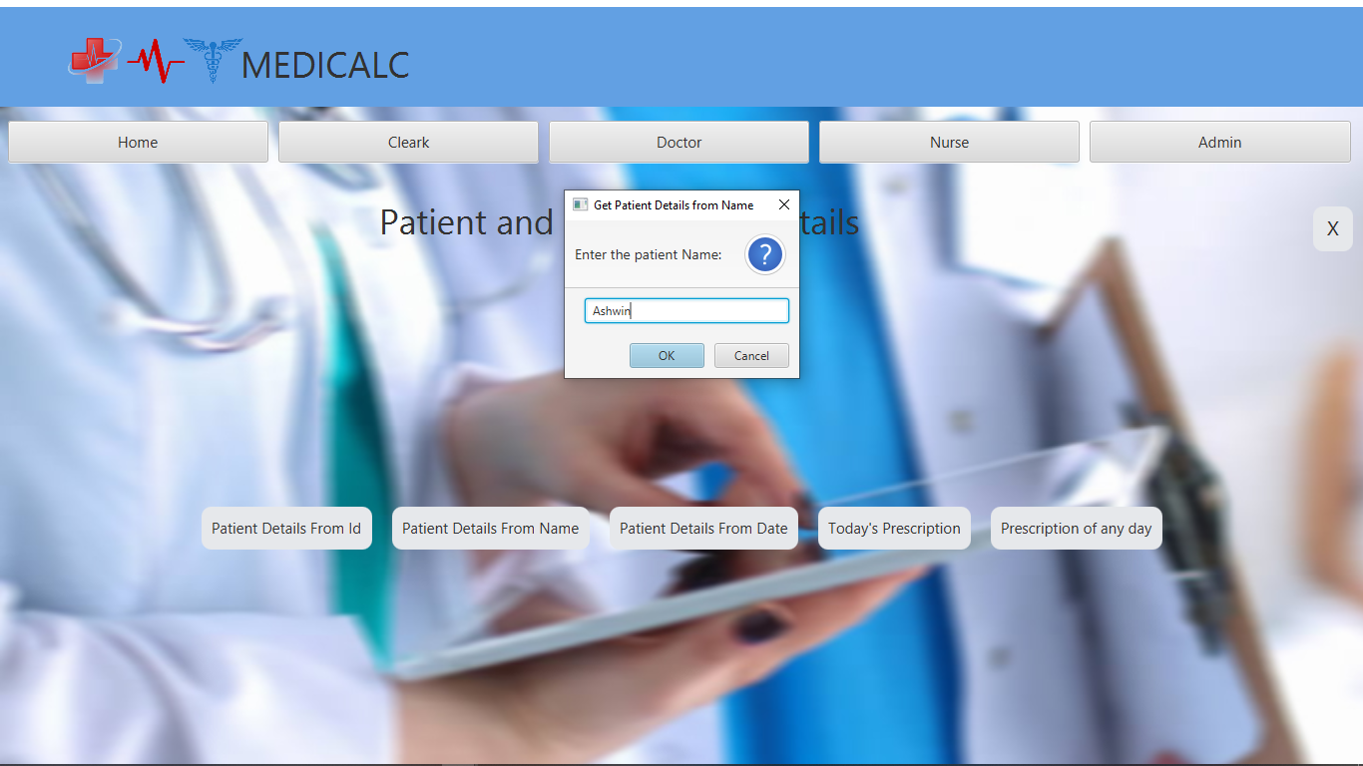 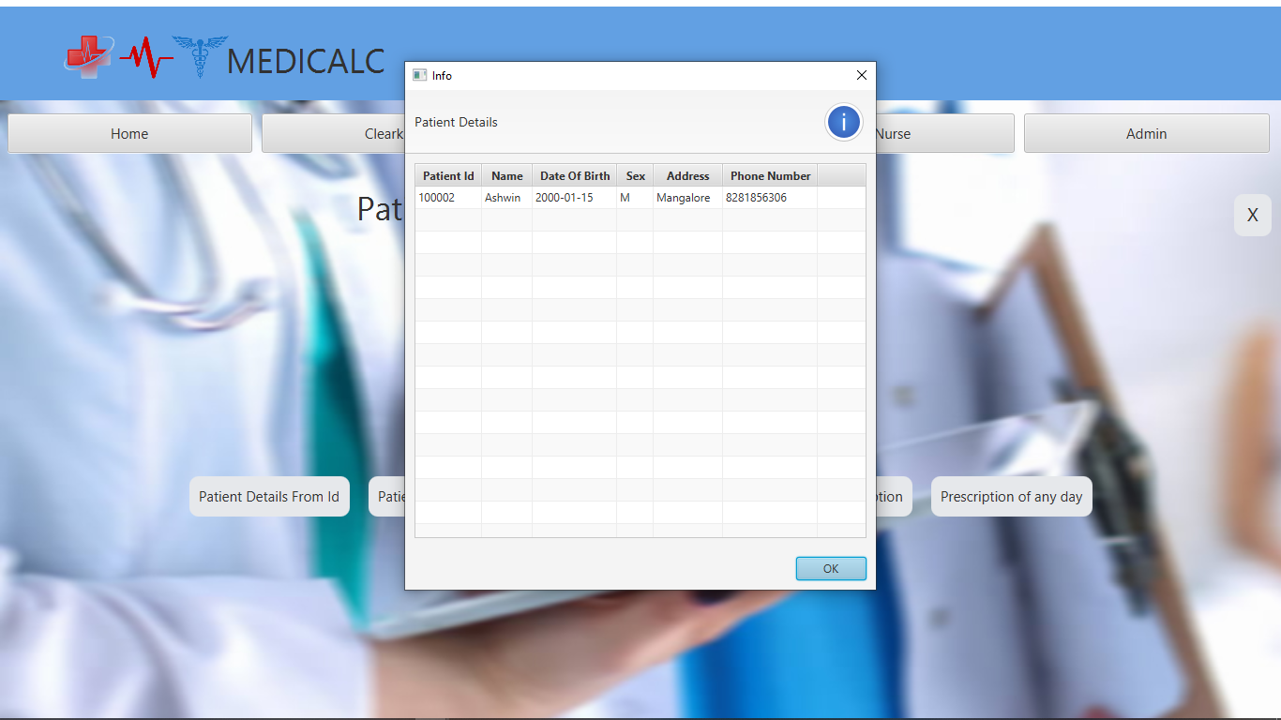 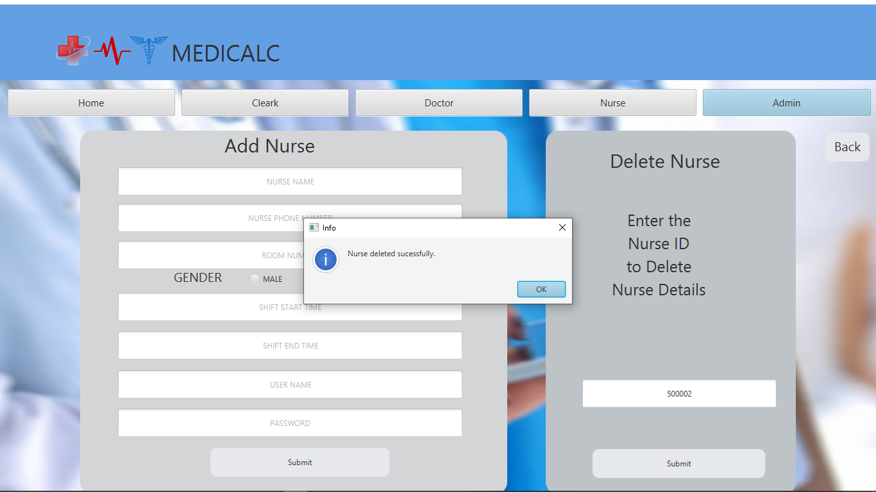 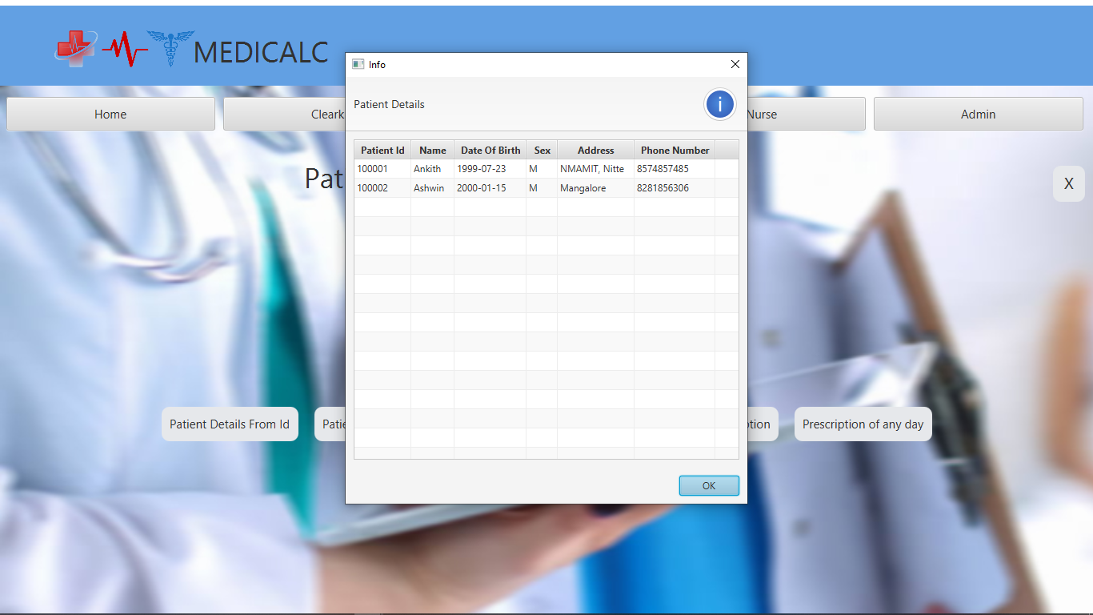 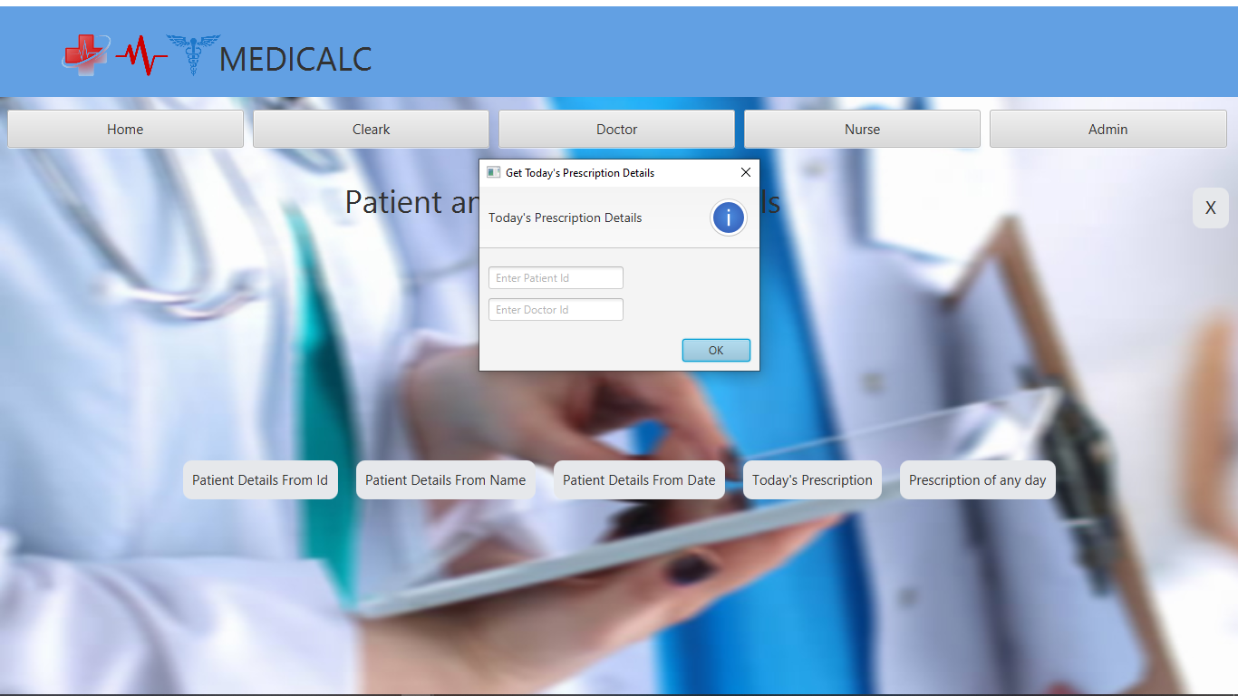 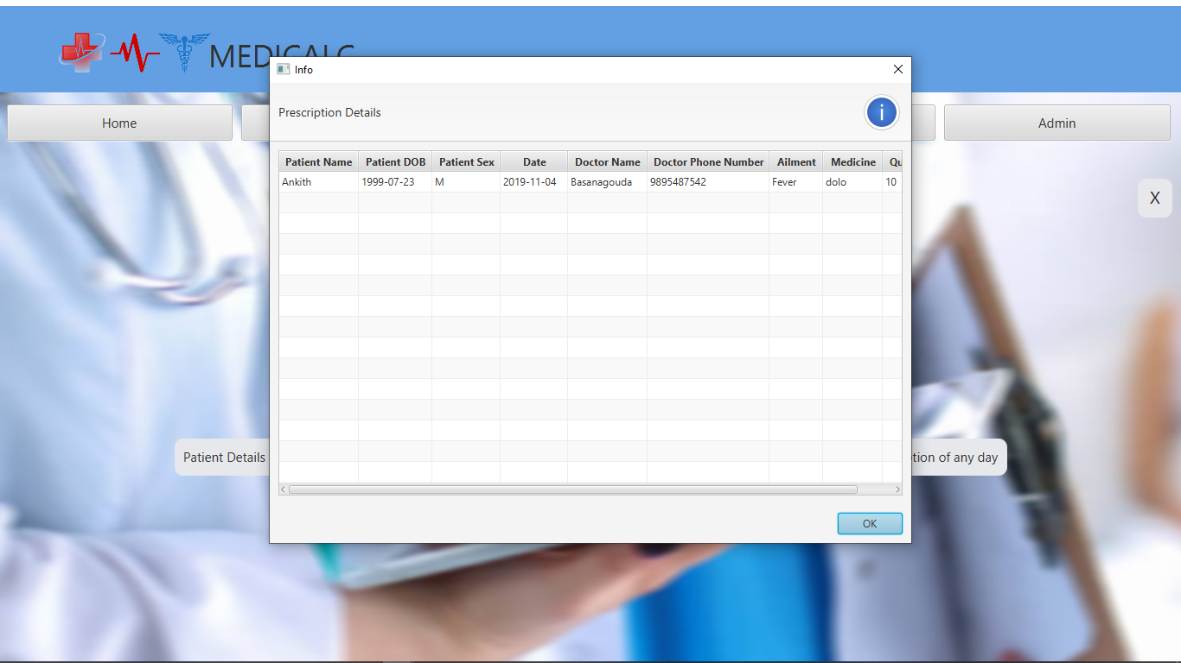 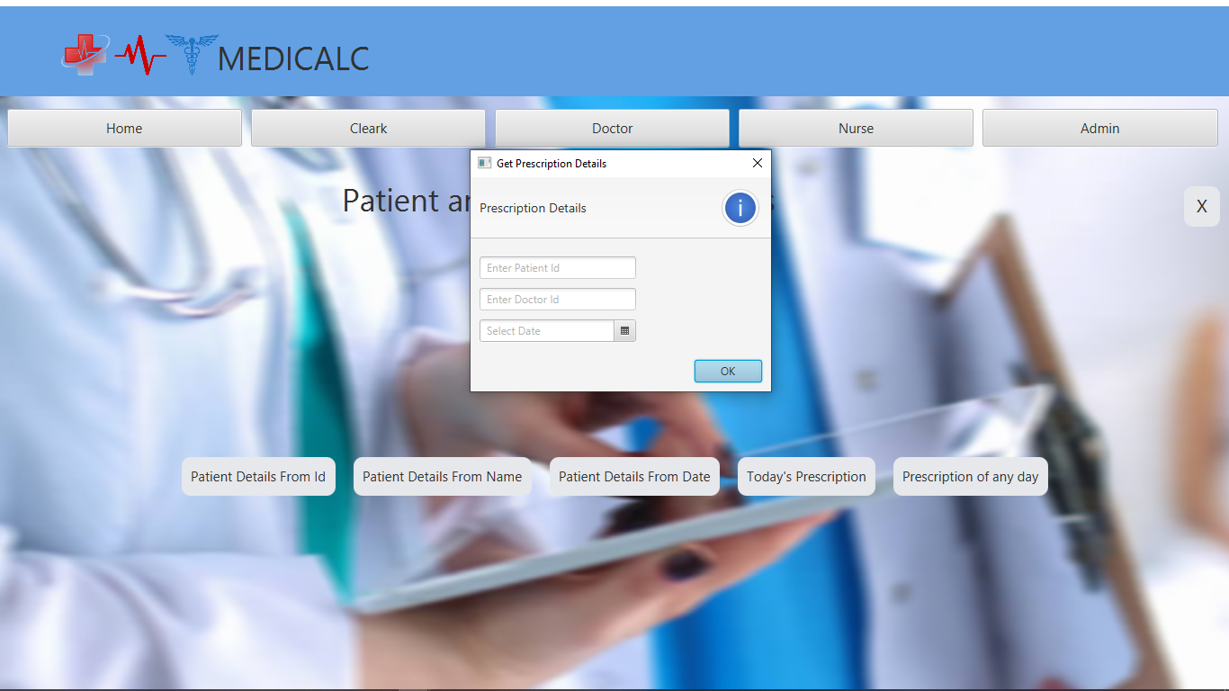 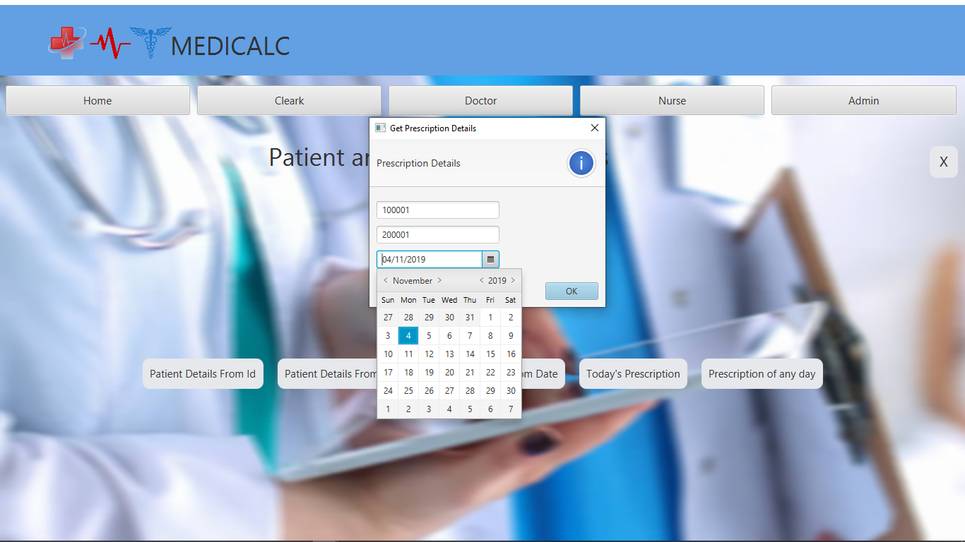 

**CHAPTER 9**

**CONCLUSION**

The “**MEDICALC**” is a clinic management tool built so as to ease the work of clinical employees in the Clinic. This tool helps to keep records of day to day activities being handled in a clinic. The database used will help in maintaining concurrency and help in retrieving data in need with any loss in consistency.

The application can be used by any small or large clinic to benefit them in handling clinical records in the clinic. The data stored is durable and can be used even to form a data warehouse.

**CHAPTER 10**

**REFERENCES**

**1.** [**www.stackoverflow.com**](http://www.stackoverflow.com)

**2.** [**www.youtube.com**](http://www.youtube.com)

**3. www.geeksforgeeks.com**